**An improved protocol for identification and analysis of driver genes using multi-omics data**

Quang-Huy Nguyen1,2, Duc-Hau Le 1,3,*

1Department of Computational Biomedicine, Vingroup Big Data Institute, Hanoi, Vietnam.

2School of Pharmacology, Dainam University, Hanoi, Vietnam.

3School of Computer Science and Engineering, Thuyloi University, Hanoi, Vietnam.

* corresponding author: Email: [hauldhut@gmail.com](mailto:hauldhut@gmail.com); Tel: (84)912324564

**User manual**

Table of Contents

1. Introduction 3

2. Dataset 3

3. Identification of driver genes using OncodriveFML and OncodriveCLUSTL (Fig.1, Stage 1; Step 1) 4

4. Enrichment Analysis using g:Profiler (Fig.1, Stage 2; Step 2) 6

5. Individual gene-clinical feature association analysis (Fig.1, Stage 2; Step 3) 7

5.1. Association between individual driver genes and survival rate 7

5.2. Identify which driver genes are significantly correlated with other clinical features 8

6. Co-expressed module-clinical feature association analysis using WGCNA (Fig.1, Stage 2; Step 4) 9

6.1. Weighted co-expression driver gene network construction. 9

6.2. Detect associations of functional modules to clinical features, identification of significant genes and hub genes in each of those modules. 12

7. Patient stratification (Fig.1, Stage 2; Step 5) 16

7.1. Pre-processing clinical data & CNVs data 16

7.2. Patient stratification by the identified driver genes 16

7.3. Comparision between the identified patient groups 19

8. References 24

# 1. Introduction

The cumulative of genes carrying mutations is vital for the establishment and development of cancer. However, this line of driver gene exploring research has selected and used types of tools and models of analysis unsystematically and discretely. Also, the previous studies may have neglected low-frequency drivers, non-coding drivers and seldom predicted subgroup specificities of identified driver genes. In this document, we propose a protocol integrating state-of-the-art tools to solve the above challenges using the breast cancer (BRCA) dataset as an example (Fig.1).



**Figure. 1 | Protocol for identification and analysis of driver genes**. The protocol comprises two stages: identification and analysis, in which the former uses the OncodriveFML and OncodriveCLUSTL to identify driver genes with somatic mutation data as input, and the latter performs the four most widely focused analyses to deal with those driver genes. Abbreviation: CNV, Copy number variations.

Here, we use the METABRIC breast cancer (BRCA) dataset [1] as an example to demonstrate the use of our protocol to (Stage 1) identify and (Stage 2) analyze the driver genes.

# 2. Dataset

The breast cancer data are downloaded from the cBioPortal for Cancer Genomics (<http://www.cbioportal.org)> [2]. It contains METABRIC breast cancer cohort assembled from 2,509 primary breast cancer patients with 548 matched normals in the United Kingdom and Canada [3]. The gene expression microarray data are generated using the Illumina Human v3 microarray for 1,904 samples, while the CNVs data are measured on the Affymetrix SNP 6.0 platform for 2,173 samples, and17,272 somatic mutations of 173 genes for 2,369 samples are generated on the Illumina HiSeq 2,000 platform.

Each data type is a tabular file with a header that must contain, at least, the following columns:

|  |  |  |
| --- | --- | --- |
| File | Data type | Format (Data fields) |
| data_mutations_extended.txt | Mutation | - For OncodriveFML:  http://bbglab.irbbarcelona.org/oncodrivefml/faq#qfilesformat  - For OncodriveCLUSTL:  http://bbglab.irbbarcelona.org/oncodriveclustl/faq#qmutfileformat |
| data_mRNA_median_Zscores.txt | Gene expression | - Hugo_Symbol: gene names  - The remaining columns are BRCA patients |
| data_CNA.txt | Copy number aberration | - Hugo_Symbol: gene names  - The remaining columns are BRCA patients |
| data_clinical_patient.txt | Clinical feature  (traits) | 1. PATIENT_ID  2. LYMPH_NODES_EXAMINED_POSITIVE: Number of positive lymph nodes  3. stage: Tumor stages  5. NPI: Nottingham prognostic index  6. OS_MONTHS: Follow-up months  7. OS_STATUS: BRCA patients’ status |

**Table 1. The description of data used in the study.** The format of all data types used in the study.

# 3. Identification of driver genes using OncodriveFML and OncodriveCLUSTL (Fig.1, Stage 1; Step 1)

Identification of driver genes in BRCA is implemented using the two tools OncodriveCLUSTL 1.1 [4] and OncodriveFML 1.0 [5]. They are available as a friendly web-based application at <http://bbglab.irbbarcelona.org/oncodriveclustl/analysis> and [http://bbglab.irbbarcelona.org/oncodrivefml/analysis#](http://bbglab.irbbarcelona.org/oncodrivefml/analysis), respectively. Both of them require a specific format data that can refer to the heading **?FAQ** at each below the corresponding website. In general, the requirement is simple, and the somatic mutation data from popular omics data sources (e.g., METABRIC and TCGA) meets it at the origin format; therefore, directly upload the file *data_mutations_extended.txt* to each tool. The parameters of each tool are set to default values with the exception of the sequencing parameter (targeted sequencing) and the scoring system CADD v1.3 [6] (the latest version at the time of this writing) in the OncodriveFML tool.

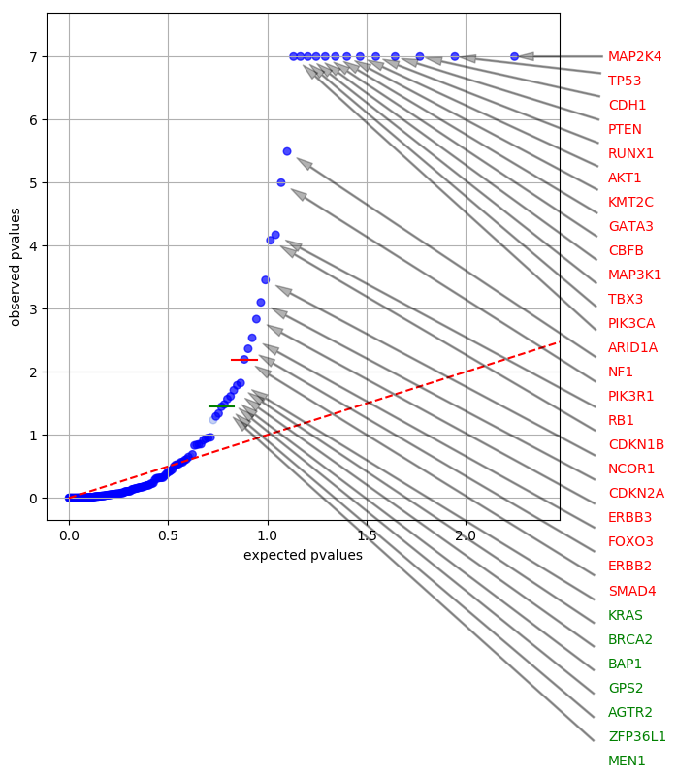

**Figure 2 | OncodriveFML result.** List of driver genes is predicted by OncodriveFML. A comprehensive list of driver genes can be found from the downloaded tsv file, *<day of the file created>_input-oncodrivefml*.*tsv*.

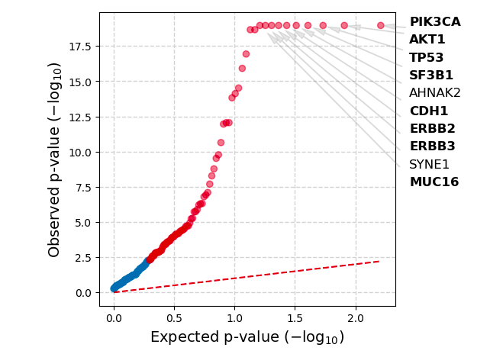

**Figure 3 | OncodriveCLUSTL result.** List of driver genes is predicted by OncodriveCLUSTL. A comprehensive list of driver genes can be found from the downloaded compressed zip file, *<day of the file created>_compressed_file.zip*.

As a result, collectively combining two sets of driver genes from the above figures, a total of 35 unique driver genes are detected by the two tools (Supplementary File 2, Table S1).

# 4. Enrichment Analysis using g:Profiler (Fig.1, Stage 2; Step 2)

The protocol identify significantly enriched GO biological processes and KEGG pathways using g:Profiler to characterize the functional enrichment of all driver genes. Specific procedures are shown as follows:

Firstly, users can open the g:Profiler website at <https://biit.cs.ut.ee/gprofiler/gost>. Input is 35 identified driver genes (Supplementary File 2, Table S1). In ‘Data sources’ tab, we only choose ‘GO biological process’ option under the sub-tab ‘Gene Ontology’ and ‘KEGG’ option under the sub-tab ‘biological pathways’.The remaining options are excluded or kept as they are. Finally, click ‘Run query’ to get the results. A full list of enriched GO terms and pathways can be downloaded by clicking the button ‘CSV’ in the ‘Detailed Results’ tab. The downloaded result is a csv file, *gProfiler_<organism>_<day of the file created>_<time of day of the file created>__intersections.csv.*

As a result, g:Profiler yields 453 significantly enriched biological processes (Supplementary File 2, Table S4) and 66 significantly enriched KEGG pathways (Supplementary File 2, Table S5).

Because g:Profiler is an up-to-date gene enrichment analysis tool, the results can not be reproduced if using in a different version. The version of g:Profiler in this protocol is e99_eg46_p14_f929183. Users can find the older versions from <https://biit.cs.ut.ee/gprofiler/archives/>.

# 5. Individual gene-clinical feature association analysis (Fig.1, Stage 2; Step 3)

Firstly, we must setup and load some essential libraries and data objects. Then, we pre-process gene expression data & clinical data. Specifically, we only retain 1,904 BRCA patients having both clinical and gene expression data for the 35 identified driver genes.

*#Pre-processing gene expression data & clinical data*

source("1.Clinical-preprocess.R")

# 5.1. Association between individual driver genes and survival rate

For step 3 (Fig. 1, stage 2), source the R.script (2.Clinical-SA.R) that contains:

* Prepare the data by creating event vector for median expression data, in which values above the median are assigned as up-regulated (= “up”), and values below the median are assigned as down-regulated (= “down”). This can be done using the function apply()*.*
* The function ‘geneSA’ implements a log-rank test in univariate Cox regression analysis with a proportional hazards model to associate the expression of each driver gene with the overall survival of the patients automatically and separately. Then, the function ‘computeQ’ computes Q-values. The function will report hazard ratios (column ‘HR’), 95% confidence intervals (column ‘confidence_intervals’), P-values, and Q-values of each driver gene.

*#library*

if(!require(devtools)) install.packages("devtools")

devtools::install_github("huynguyen250896/geneSA")

library(geneSA)

*#check what driver genes are significantly correlated with survival rate*

source("2.Clinical-SA.R")

Table 2 shows 15 driver genes significantly correlated with survival rate.

|  |  |  |
| --- | --- | --- |
| **Gene** | **HR (95% CI)** | **P-value** |
| AKT1 | 1.30 (1.15-1.46) | 1.59×10-05 |
| CDH1 | 1.15 (1.02-1.30) | 0.02 |
| KMT2C | 1.24 (1.10-1.40) | 3.65×10-04 |
| KRAS | 1.20 (1.07-1.35) | 2.32×10-03 |
| MUC16 | 1.17 (1.04-1.32) | 8.45×10-03 |
| NF1 | 1.13 (1.00-1.27) | 0.04 |
| NCOR1 | 0.87 (0.78-0.98) | 0.03 |
| CDKN1B | 0.88 (0.78-0.99) | 0.03 |
| MAP2K4 | 0.76 (0.67-0.85) | 4.67×10-06 |
| MAP3K1 | 0.82 (0.73-0.93) | 1.22×10-03 |
| PIK3R1 | 0.84 (0.75-0.95) | 4.37×10-03 |
| PTEN | 0.85 (0.76-0.96) | 7.91×10-03 |
| SMAD4 | 0.78 (0.69-0.88) | 5.14×10-05 |
| SYNE1 | 0.78 (0.70-0.88) | 6.45×10-05 |
| TBX3 | 0.84 (0.75-0.95) | 4.91×10-03 |

**Table 2.** **Association between the expression of driver genes and the overall survival of BRCA patients**. Six genes including *AKT1, CDH1, KMT2C,* *KRAS, MUC16 and NF1* with above-median expression levels and nine genes including *NCOR1,* *CDKN1B, MAP2K4, MAP3K1, PIK3R1, PTEN, SMAD4, SYNE1,* and *TBX3* with below-median expression levels significantly associated with a shortened lifespan. (down-regulation is the reference). Hazard ratio (HR) is a measure that helps to determine whether either of two expression levels of each driver gene will result in an increased (i.e., HR > 1) or decreased (i.e., HR < 1) probability of experiencing the defined event (i.e., death), at any time (in this case, the below-median expression level is the reference). P-values are computed by the Cox proportional hazard method to test the statistical difference between the given results.

# 5.2. Identify which driver genes are significantly correlated with other clinical features

We identify which driver genes are significantly correlated with other clinical features, including numbers of lymph nodes, the Nottingham prognostic index, and the pathologic stages. Specifically, ‘computeC’ computes the correlation coefficients between drivers and clinical features based on Spearman’s rank correlation; meanwhile, ‘computeQ’ computes Q-values. The function will report correlation coefficients (column ‘Estimate’), p-values, and q-values of each driver gene with each clinical feature of interest.

*#library*

devtools::install_github("huynguyen250896/computeC")

library(computeC) #compute the correlation

*#check what driver genes are significantly correlated with three other clinical features*

source("3.Clinical-corr.R")

|  |  |  |  |  |  |  |  |  |  |
| --- | --- | --- | --- | --- | --- | --- | --- | --- | --- |
| **Gene** | **Number of lymph nodes** | | | **Nottingham prognostic index** | | | **Cancer Stage** | | |
| **CC** | **P-value** | **Q-value** | **CC** | **P-value** | **Q-value** | **CC** | **P-value** | **Q-value** |
| ARID1A | -0.06 | 0.01 | 0.02 | -0.13 | 1.31×10-8 | 3.20×10-8 | -0.10 | 1.13×10-4 | 4.73×10-4 |
| RUNX1 | -0.14 | 1.65×10-9 | 3.63×10-8 | -0.25 | 2.20×10-16 | 2.42×10-15 | -0.11 | 2.97×10-5 | 3.12×10-4 |
| GATA3 | -0.01 | 1.27×10-5 | 9.31×10-5 | -0.28 | 2.20×10-16 | 4.84×10-15 | -0.12 | 3.83×10-5 | 2.68×10-4 |
| TBX3 | -0.10 | 9.10×10-6 | 1.00×10-4 | -0.18 | 1.44×10-15 | 6.31×10-15 | -0.12 | 6.12×10-5 | 3.21×10-4 |
| NF1 | -0.09 | 5.77×10-5 | 3.17×10-4 | -0.08 | 2.23×10-4 | 3.07×10-4 | -0.07 | 6.36×10-3 | 0.02 |
| MAP2K4 | -0.08 | 4.61×10-4 | 1.69×10-3 | -0.22 | 2.20×10-16 | 1.21×10-15 | -0.07 | 6.99×10-3 | 0.02 |
| PTEN | -0.08 | 6.02×10-4 | 1.89×10-3 | -0.23 | 2.20×10-16 | 1.61×10-15 | -0.11 | 2.93×10-5 | 6.15×10-4 |
| SMAD4 | -0.06 | 0.01 | 0.03 | -0.10 | 1.79×10-5 | 3.29×10-5 | -0.08 | 1.48×10-3 | 3.89×10-3 |
| MAP3K1 | -0.06 | 0.01 | 0.03 | -0.16 | 6.35×10-13 | 2.00×10-12 | -0.09 | 7.16×10-4 | 2.15×10-3 |
| SF3B1 | 0.09 | 7.83×10-5 | 1.02×10-3 | 0.07 | 1.78×10-3 | 3.31×10-3 | 0.10 | 8.48×10-5 | 1.19×10-3 |

**Table 3. Association between the expression of driver genes and the other clinical features.** *ARID1A, RUNX1, GATA3, TBX3, NF1, MAP2K4, PTEN, SMAD4, MAP3K1* and *SF3B1* significantly associated with all of the three clinical features. The column ‘CC’ (i.e., correlation coefficient denoted by r) measures the degree of association between the two variables: each driver gene versus each clinical feature. It takes on values ranging between -1 and +1. When r = 0, there is no relationship between the two variables. When r closer to 1, there is an increasingly strong positive (uphill) relationship between the two variables, otherwise is an increasingly strong negative (downhill) relationship between the two variables. CC: correlation coefficient.

# 6. Co-expressed module-clinical feature association analysis using WGCNA (Fig.1, Stage 2; Step 4)

We first install all the required packages before the analysis and set up a basic setting following the WGCNA’s recommendation.

*#library*

install.packages(c("dynamicTreeCut","flashClust","Hmisc","WGCNA"))

if(!requireNamespace("BiocManager", quietly = TRUE))

install.packages("BiocManager")

BiocManager::install("preprocessCore")

library("dynamicTreeCut"). *# Module identification*

library("flashClust") *# Fast implementation of hierarchical clustering*

library("Hmisc") *#perform variables clustering*

library("WGCNA") *#WGCNA tool*

library(purrr)  *#data processing*

library(cluster) *# compute agglomerative coefficient*

*# The following setting is important, do not omit.*

options(stringsAsFactors = FALSE);

enableWGCNAThreads()*# Allowing parallel execution*

# 6.1. Weighted co-expression driver gene network construction.

# The function ‘pickSoftThreshold’ helps to find the optimal soft threshold tomake the co-expression matrix of the identified drivers fit a scale-free topology model. The set of soft-thresholding powers is default following the recommendation of WGCNA’s authors. As shown in Fig.4, the protocol recommends choosing a point at which R2 reaches the peak for the first time (y-axis), as described in the paper [7]. From that, we choose the soft-power β = 7.

*#create clinical_exp1 for this step*

clinical_exp1 = clinical_exp[,-c(3,5:6)] #remove OS_MONTHS, OS_STATUS and status columns

*# Choose a set of soft-thresholding powers*

powers = c(c(1:10), seq(from = 12, to=20, by=2))#1,2,3,4,5,6,7,8,9,10,12,14,16,18,20

*# Call the network topology analysis function*

sft = pickSoftThreshold(t(exp_dri_norm), powerVector = powers, verbose = 5, networkType = "signed")

*# Plot the results:*

sizeGrWindow(9, 5)

cex1 = 0.9;

*# Scale-free topology fit index as a function of the soft-thresholding power*

plot(sft$fitIndices[,1], -sign(sft$fitIndices[,3])*sft$fitIndices[,2],

xlab="Soft Threshold (power)",ylab="Scale Free Topology Model Fit,signed R^2",type="n",

main = paste("Scale independence"));

text(sft$fitIndices[,1], -sign(sft$fitIndices[,3])*sft$fitIndices[,2],

labels=powers,cex=cex1,col="red");

*# this line corresponds to using an R^2 cut-off of h*

abline(h=0.305,col="red")

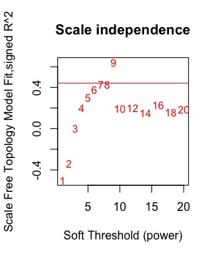

**Figure 4 | Analysis of network topology for various soft-thresholding powers.** The graph shows the scale-free fit index (y-axis) as a function of the soft-thresholding power β (x-axis).

We now calculate the adjacencies using the function ‘adjacency’ with identified soft-power β = 7, then turn the adjacency to Topological Overlap Matrix (TOM) with the function ‘TOMsimilarity’ before calculating the corresponding dissimilarity:

*# Calculate the adjacencies*

softPower = 7;

adjacency = adjacency(t(exp_dri_norm), power = softPower,

type = "signed");

# Turn adjacency into topological overlap

TOM = TOMsimilarity(adjacency, TOMType = "signed");

dissTOM = 1-TOM

The functions ‘pickSoftThreshold’, ‘adjacency’, and ‘TOMsimilarity’ use respectively the arguments ‘networkType’, ‘type’, and ‘TOMType’ to allow the user to construct a signed or unsigned network.

Next, detect the co-expressed modules and plot them:

(i) Creation of a gene tree

* Perform agglomerative hierarchical clustering using the ‘agnes’ function to get the agglomerative coefficient. As a result, Ward’s method (i.e., ward.D2) is the best solution.
* The function ‘hclust’creates a gene tree (Fig.5 and the top side of Fig. 6) by combining a dissimilarity matrix of all the drivers, calculated based on Pearson’s correlation, with Ward’s method, finding the relationship between the driver genes.

(ii) Identification of co-expressed modules based on the gene tree.

* The function ‘cutreeDynamic’ for the dynamicTreeCut package distributes the identified driver genes to each resulting module

(iii) The function ‘plotDendroAndColors’ visualizes the identified co-expressed modules which are colored separately (Fig.6).

*# methods to assess*

*m <- c( "average", "single", "complete", "ward")*

*names(m) <- c( "average", "single", "complete", "ward")*

*# function to compute agglomerative coefficient*

*set.seed(2583)*

*ac <- function(x) {*

*agnes(exp_dri_norm, method = x)$ac*

*}*

*map_dbl(m, ac) # Agglomerative coefficient of each agglomeration method*

*#assign gene names from adjacency to dissTOM*

*rownames(dissTOM) = rownames(adjacency)*

*colnames(dissTOM) = colnames(adjacency)*

*# Call the hierarchical clustering function*

*geneTree = hclust(as.dist(dissTOM), method = "ward.D2");*

*# Plot the resulting clustering tree (dendrogram)*

sizeGrWindow(12,9)

plot(geneTree, xlab="", sub="", main = "Gene clustering on TOM-based dissimilarity",cex.lab = 1,cex.axis = 1, cex.main = 1.2);

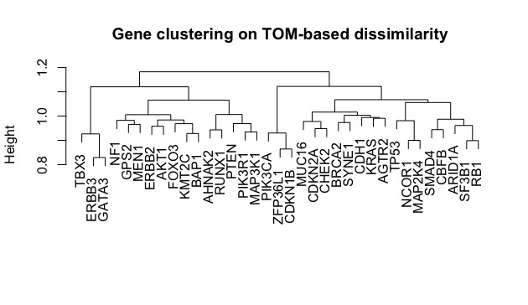

**Figure 5 | Gene tree.** Clustering dendrogram of genes, with dissimilarity based on topological overlap, together with assigned module colors.

*#We set the minimum module size at 10:*

*minModuleSize = 10;*

*# Module identification using dynamic tree cut:*

*dynamicMods = cutreeDynamic(dendro = geneTree, distM = dissTOM,*

*minClusterSize = minModuleSize);*

Argument ‘minClusterSize’ designates the minimum number of driver genes appearing in each identified module. At best, according to prior studies, users should consider choosing 10 for reproducibility. The other ones should be left at default.

*# Convert numeric lables into colors*

moduleColors = labels2colors(moduleColors )

*# Plot the dendrogram and colors underneath*

sizeGrWindow(5,6)

plotDendroAndColors(geneTree, moduleColors, "Module Colors",

dendroLabels = FALSE, hang = 0.03,

addGuide = TRUE, guideHang = 0.05,

main = "Gene dendrogram and module colors")

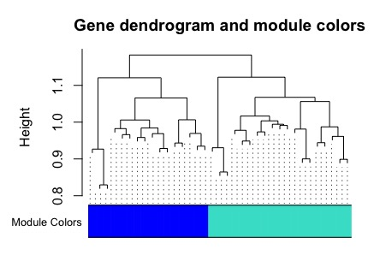

**Figure 6 | Gene dendrogram and module colors.** Clustering dendrogram of genes, with dissimilarity based on the topological overlap, together with assigned module colors.

# 6.2. Detect associations of functional modules to clinical features, identification of significant genes and hub genes in each of those modules.

# The function ‘labeledHeatmap’ further analyzes and visualizes the associations between the identified modules and clinical features. The resulting color-coded table is shown in Fig. 7.

*#Define numbers of genes and samples*

nGenes = ncol(t(exp_dri_norm));

nSamples = nrow(t(exp_dri_norm));

*# Recalculate MEs with color labels*

MEs0 = moduleEigengenes(t(exp_dri_norm), moduleColors)$eigengenes

MEs = orderMEs(MEs0)

moduleTraitCor = cor(MEs, clinical_exp1, use = "p");

moduleTraitPvalue = corPvalueStudent(moduleTraitCor, nSamples);

*sizeGrWindow(20,6)*

*# Will display correlations and their p-values*

textMatrix = paste(signif(moduleTraitCor, 2), "\n(",

signif(moduleTraitPvalue, 1), ")", sep = "");

dim(textMatrix) = dim(moduleTraitCor)

par(mar = c(6, 8.5, 3, 3));

*# Display the correlation values within a heatmap plot*

labeledHeatmap(Matrix = moduleTraitCor,

xLabels = names(clinical_exp1),

yLabels = names(MEs),

ySymbols = names(MEs),

colorLabels = FALSE,

colors = blueWhiteRed(50),

textMatrix = textMatrix,

setStdMargins = FALSE,

cex.text = 0.8,

zlim = c(-1,1),

main = paste("Module-clinical feature relationships"))

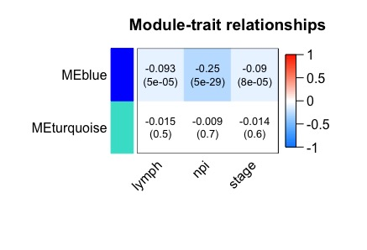

**Figure 7 | Co-expressed module–feature associations.** Each row corresponds to a module, column to a clinical feature. Each cell contains the correlation coefficient and its corresponding p-value. Abbreviation: lymph, numbers of lymph nodes, npi, Nottingham prognostic index, stage, tumor stages.

We discover significant genes (i.e., high Gene significance and high Module membership, Figure 7) in a single module having a significant association with clinical features (the blue module is an example, the others can be done similarly)

*####blue # names (colors) of the modules # Define variable stage containing the stage column of exp_dri_norm*  stage = as.data.frame(clinical_exp1$stage); names(stage) = "stage" *# names (colors) of the modules* modNames = substring(names(MEs), 3) geneModuleMembership = as.data.frame(cor(t(exp_dri_norm), MEs, use = "p")); MMPvalue=as.data.frame(corPvalueStudent(as.matrix(geneModuleMembership), nSamples)); names(geneModuleMembership) = paste("MM", modNames, sep=""); names(MMPvalue) = paste("p.MM", modNames, sep=""); geneTraitSignificance=as.data.frame(cor(t(exp_dri_norm), stage, use = "p")); GSPvalue=as.data.frame(corPvalueStudent(as.matrix(geneTraitSignificance), nSamples)); names(geneTraitSignificance) = paste("GS.", names(stage), sep=""); names(GSPvalue) = paste("p.GS.", names(stage), sep="");

*#Intramodular analysis: identifying genes with high GS and MM* module = "blue" column = match(module, modNames); moduleGenes = moduleColors==module; sizeGrWindow(7, 7); par(mfrow = c(1,1)); x <- abs(geneModuleMembership[moduleGenes, column]) y <- abs(geneTraitSignificance[moduleGenes, 1]) limit <- range(c(x,y)) r <- round(cor(x,y),2) plot( x,

y,

ylim =range(0.00,0.25), xlim =range(0.1,0.7),

xlab =paste("Module Membership in", module, "module"),

ylab ="Gene significance for stage", col = module)

fit <-lm(y~x) pintra= round(summary(fit)$coefficients[,4][[2]],2) #p-value abline(fit, col='orange') legend('topleft', col = "orange", lty = 1, box.lty = 1,legend='regression line', cex= 0.8) mtext(paste('correlation = ', r, ",", "P-value = ", pintra)) title(paste("Module membership vs. gene significance\n")) text(y~x,labels=rownames(exp_dri_norm)[moduleColors=="blue"],data=exp_dri_norm, cex=0.8, font=4, pos = 3) *#add label*

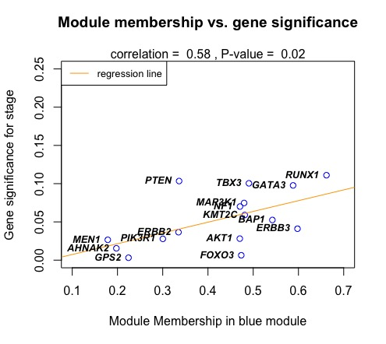

**Figure 8 | Module membership and gene significance.** A correlation of the blue module to the tumor stages with all genes in it.

Alternatively, the function verboseScatterplot provided in the package WGCNA can generate the similar result in Figure 8 in a more easier way, but users can not draw a regression line (orange) and add gene names next to the corresponding blue circles:

*#Alternatively* verboseScatterplot(abs(geneModuleMembership[moduleGenes, column]),

abs(geneTraitSignificance[moduleGenes, 1]),

xlab = paste("Module Membership in", module,"module"),

ylab = "Gene significance for npi",

main = paste("Module membership vs. gene significance\n"),

cex.main = 1.2, cex.lab = 1.2, cex.axis = 1.2, col = module)

These below scripts help detect significant genes (high Gene significance and high Module membership) and the top 5 hub genes in each module (the turquoise module is an example, the others can be done similarly), respectively.

*#identifying genes with high GS and MM*

intra_modular_analysis=data.frame(abs(geneModuleMembership[moduleGenes, column]),abs(geneTraitSignificance[moduleGenes, 1])) rownames(intra_modular_analysis)=colnames(t(exp_dri_norm))[moduleColors=="blue"] *#only the blue* module View(intra_modular_analysis)

*#high intramodular connectivity ~ high kwithin => hub genes (kwithin: connectivity of the each driver gene in the turquoise module to all other genes in the turquoise)*

connectivity=intramodularConnectivity(adjacency, moduleColors)

connectivity=connectivity[colnames(t(exp_dri_norm))[moduleColors=="turquoise"],] *#only the turquoise module*

order.kWithin = order(connectivity$kWithin, decreasing = TRUE)

connectivity = connectivity[order.kWithin,] #order rows following kWithin

connectivity = connectivity[1:5,] *#top 5 genes that have a high connectivity to other genes in the turquoise module*

View(connectivity)

# 7. Patient stratification (Fig.1, Stage 2; Step 5)

# 7.1. Pre-processing clinical data & CNVs data

Source the R.script (1.CNA-preprocess.R) to process the two datasets: CNV data and clinical data.

*#Load data objects and Data Preprocessing*

source("1.CNA-preprocess.R")

# 7.2. Patient stratification by the identified driver genes

Source the R.script (2.CNA-hclut.R) to do this task that contains:

* A same way in a above step, we find the best agglomeration method (i.e., Ward’s method) using the function ‘agnes’ and realize that Ward’s method outperforms the others again.
* The function ‘hclust’ generates a dendrogram tree of the patients by combining a dissimilarity matrix of all the patients, computed based on Euclidean distance by the function ‘dist’, with Ward’s method, finding the relationship between all the patients.
* The function ‘clValid’ performs the Dunn’s index (Figure 9) and the average Silhouette width (Figure 10) to determine how many patient groups are best. Collectively, Fig.9-11 imply that two groups are the best solution.
* The function ‘cutree’ with ‘agnes’ distributes all the patients to each of two groups
* The function ‘Heatmap’ for the package ComplexHeatmap plots the result of patient stratification as a heatmap plot (Fig.12).

*#Patient stratification*

source("2.CNA-hclut.R")

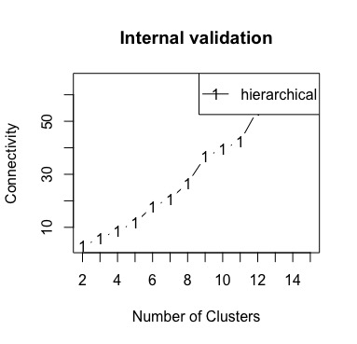

**Figure 9 |**  **Optimal group number detection.** The connectivity computes the degree of connectedness of a given group partitioning. The connectivity shows the connectedness of a given cluster partitioning and has a value between 0 and infinity. The user should choose a point reaching the most minimized value (y-axis).



**Figure 10 |**  **Optimal group number detection.** Two optimal groups were determined by the Dunn’s index. The Dunn’s index (y-axis) has a value between zero (poorly clustered observations) and infinity (well clustered observations), and the place where the black line of Dunn’s index plot peaks at, which implies that that group number is optimal.



**Figure 11.** **Optimal group number detection.** Two optimal groups were also determined by the Silhouette width. The average Silhouette has a value between -1 (poorly clustered observations) and 1 (well clustered observations), and the place where the black line of the Silhouette plot peaks at, which implies that that group number is optimal.

Fig. 9-11. shows that the two number of groups is the best solution.

Then, we cut the above-discovered tree of patients based on the optimal number of groups and visualize the result using a heatmap plot.

*# Cut agnes() tree into 2 groups*

hc_a <- agnes(t(cna_dri), method = "ward")

sub_grp= cutree(as.hclust(hc_a), k = 2)

*# Number of members in each cluster*

table(sub_grp)

*# sub_grp*

*# 1 2*

*# 1035 1138*

To show two groups on the top of the below heatmap plot, we must specify which patients belong to which identified groups.

*> ## make a named vector from the vector*

*> info =as.data.frame(sub_grp)*

*> colnames(info) <- c('groups')*

*> info$groups = as.character(info$groups)*

*> ## Heatmap annotation*

*> ha <- columnAnnotation(df = info)*

And finally, we visualize the result using a heatmap plot (Fig.12)

*> #visualization using heatmap plot*

*> Heatmap(cna_freq, name = "CNA scale",*

*+ show_row_names = TRUE, show_column_names = FALSE,*

*+ row_dend_reorder = TRUE, column_dend_reorder = TRUE,*

*+ clustering_distance_rows = "euclidean",*

*+ clustering_distance_columns = "euclidean",*

*+ clustering_method_rows = "ward.D2",*

*+ clustering_method_columns = "ward.D2",*

*+ top_annotation = ha*

*+ )*

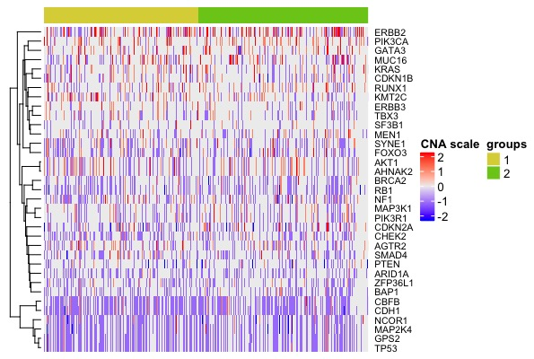

**Figure 12.** **Differences in CNVs events between the identified groups.** Clustering of BRCA patients based on 16 driver genes with the most frequent copy-number alterations. Two distinct groups are found (dark blue and green). For CNA scale, Dark red, red, grey, blue and dark blue represent high-level amplification, amplification, copy‐neutral, deletion and high-level deletion, respectively.

# 7.3. Comparision between the identified patient groups

We further perform the difference in clinical features (i.e., survival rate, number of positive lymph nodes, Nottingham prognostic index, and cancer stage) between two identified groups. Firstly, we must define the time and status of patients based on clinical data

set.seed(258)

survData<-cbind(c_clinical$OS_MONTHS, c_clinical$OS_STATUS=="DECEASED")

rownames(survData)<-rownames(c_clinical)

colnames(survData)<-c("time", "status")

survData <- as.data.frame(survData) *#coxph and survfit require input as data frame*

Then, we now fit a Cox proportional hazards regression model and compute an estimate of a survival curve using ‘coxph’ and ‘survfit’, respectively. The function ‘ggsurvplot’ for the package survminer illustrates the survival curves (Fig.13)

coxFit1 <- coxph(

Surv(time, status) ~ as.factor(sub_grp),

data = survData,

ties = "exact" )

pcox=round(summary(coxFit1)$logtest[3],8); pcox #p-value

mfit <- survfit(Surv(time, status == 1) ~ as.factor(sub_grp), data = survData)

*#visualization of survival rate between two groups*

ggsurvplot(mfit, size=1,

linetype = "strata",

risk.table = FALSE, fun ="pct", risk.table.col = "strata", break.x.by = 50,

xlab = "Time in months",

legend = "bottom",

legend.title = "Group", legend.labs = c("Group 1","Group 2"),

conf.int = TRUE, pval = paste("P-value",pcox,sep=" = " ), xlim = c(0,200))

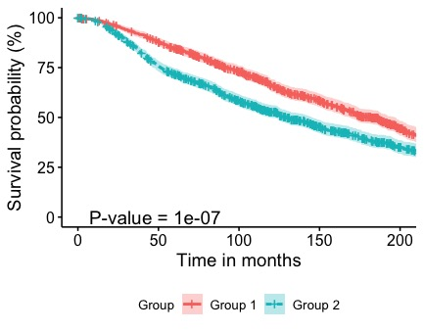

**Figure 13.** Difference in patient survival rates between the two groups.

Finally, we observe the differences between two groups with the other clinical features.

library(dplyr)

library(ggplot2)

devtools::install_github("kassambara/ggpubr")

library("ggpubr")

library(ggsci)

*#prepare data*

a =as.data.frame(sub_grp)

colnames(a) <- c('Groups')

a$lymph=c_clinical$LYMPH_NODES_EXAMINED_POSITIVE

a$npi=c_clinical$NPI

a$stage=c_clinical$stage

For the number of positive lymph node (Fig.14):

set.seed(216)

*#lymph nodes*

my_comparisons <- c("1", "2")

p=ggboxplot(a, x = "Groups", y = "lymph",

color = "Groups", palette = "npg",

ylab = "Number of positive lymph nodes", xlab = "Groups") + border("black")

ggpar(p,legend="right",legend.title = "group")

p + stat_compare_means(comparisons = my_comparisons)+

stat_compare_means(aes(label=paste0("Wilcoxon,P-value= ",..p.format..)),label.x = 0.8,label.y = 35)

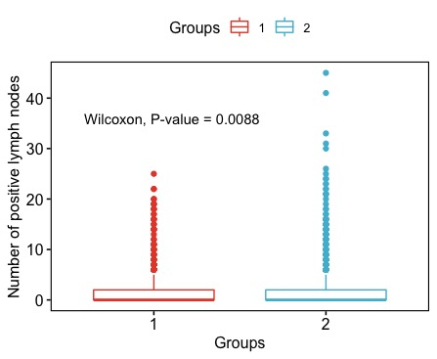

**Figure 14.** Difference in lymph between the two groups.

For the Nottingham prognostic index (Fig.15)

*#NPI*

p1<-ggboxplot(a, x = "Groups", y = "npi",

color = "Groups", palette = "npg",

ylab = "Nottingham Prognostic Index", xlab = "Groups",

bxp.errorbar=TRUE) + border("black")

ggpar(p1,legend="right", legend.title = "group")

p1 + stat_compare_means(comparisons = my_comparisons)+

stat_compare_means(aes(label=paste0("Wilcoxon,P-value= ",..p.format..)),label.x = 1.2,label.y = 7.5)

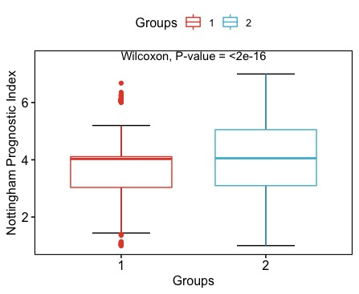

**Figure 15.** Difference in npi between the two groups.

And finally, for tumour stage (Fig.16)

*#stage*

a_st = a %>% group_by(Groups, stage) %>% summarise(patient.num = n()) ## Create a column "patient.num" which is number of patients in each combination of group and stage

a_st$Groups=as.character(a_st$Groups)

a_st$stage=as.character(a_st$stage)

a_st=na.omit(a_st)

p2=ggplot(a_st, aes(x = Groups, y = patient.num, fill = stage)) + #stacked barplot

geom_bar(position = "fill", stat = "identity") + theme(panel.background = element_blank())+ scale_y_continuous(labels = scales::percent_format())

p2 + ylab("Percent of patients")

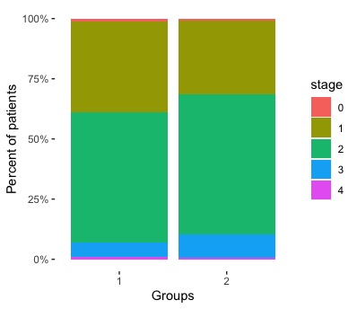

**Figure 16.** Difference in stage between the two groups.

We use the Pearson's χ2 test for this clinical feature:

library(MASS) # load the MASS package

*#test chi-square*

set.seed(357)

achitest = data.frame(a$Groups, a$stage)

achitest=na.omit(achitest)

colnames(achitest) = c("Groups", "stage")

achitest$Groups = as.character(achitest$Groups)

achitest$stage = as.character(achitest$stage)

*#tbl = table(achitest$Groups, achitest$stage)*

*# Pearson's Chi-squared test*

*#*

*#data: tbl*

*#X-squared = 14.411, df = 4, p-value = 0.006093*

*#Warning message:*

*#In chisq.test(tbl) : Chi-squared approximation may be incorrect*

# 8. References

1. Cancer Genome Atlas Research, N., et al., *The Cancer Genome Atlas Pan-Cancer analysis project.* Nature genetics, 2013. **45**(10): p. 1113-1120.

2. Cerami, E., et al., *The cBio cancer genomics portal: an open platform for exploring multidimensional cancer genomics data.* Cancer discovery, 2012. **2**(5): p. 401-404.

3. Pereira, B., et al., *The somatic mutation profiles of 2,433 breast cancers refine their genomic and transcriptomic landscapes.* Nature Communications, 2016. **7**(1): p. 11479.

4. Arnedo-Pac, C., et al., *OncodriveCLUSTL: a sequence-based clustering method to identify cancer drivers.* Bioinformatics, 2019. **35**(22): p. 4788-4790.

5. Mularoni, L., et al., *OncodriveFML: a general framework to identify coding and non-coding regions with cancer driver mutations.* Genome Biology, 2016. **17**(1): p. 128.

6. Kircher, M., et al., *A general framework for estimating the relative pathogenicity of human genetic variants.* Nature Genetics, 2014. **46**(3): p. 310-315.

7. Li, J., et al., *Application of Weighted Gene Co-expression Network Analysis for Data from Paired Design.* Scientific Reports, 2018. **8**(1): p. 622.